Name Frames
Say what you see in the three images then put your answers together to identify a famous name (1 point each)
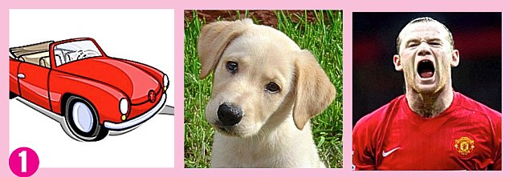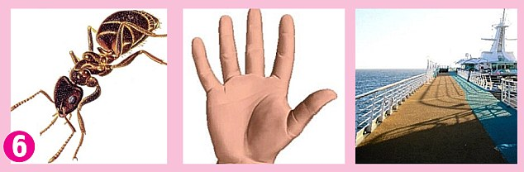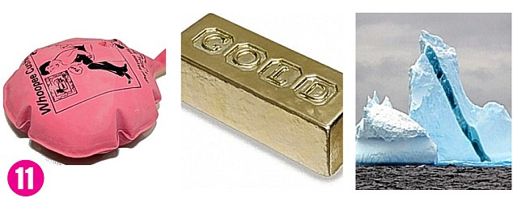
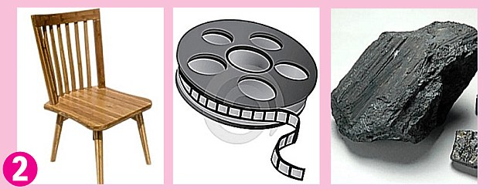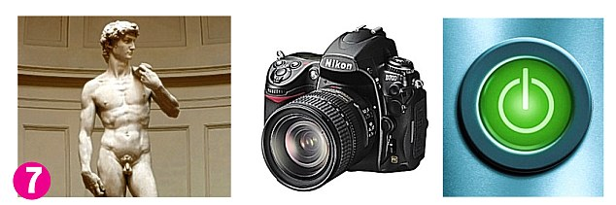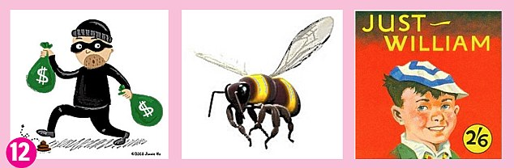

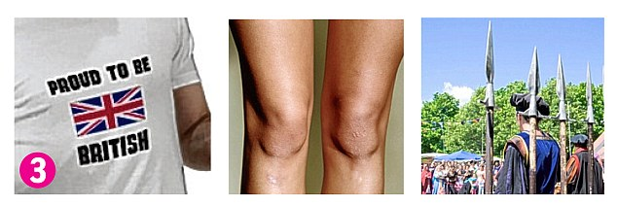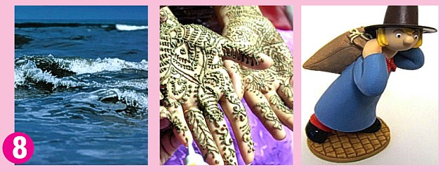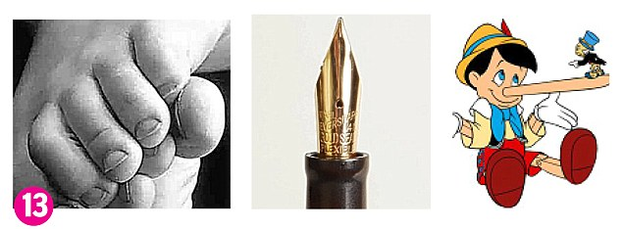

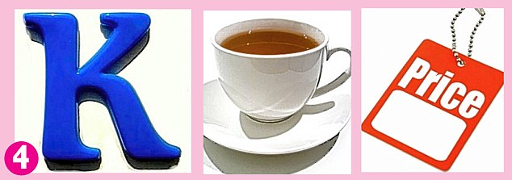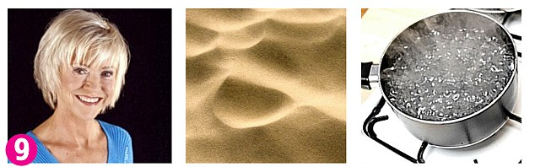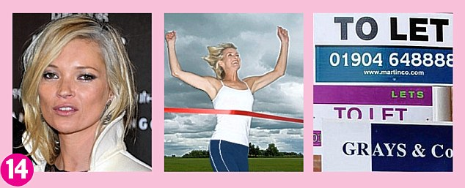

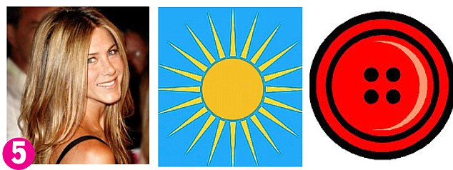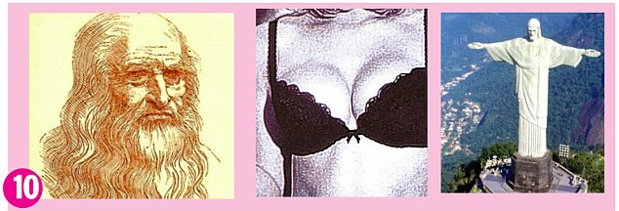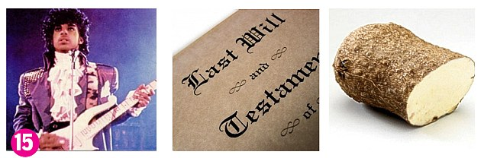

Team Name:
Score: /15

Answers:
1. Carla Bruni
2. Cheryl Cole
3. Britney Spears
4. Katie Price
5. Jenson Button
6. Ant and Dec
7. David Cameron
8. Sienna Miller
9. Susan Boyle
10. Leonardo DiCaprio
11. Whoopi Goldberg
12. Robbie Williams
13. Tony Blair
14. Kate Winslet
15. Prince William

